EXHIBIT "T"

EXHIBIT T-PAGE 1 OF 8



EXHIBIT T-PAGE 2 OF 8

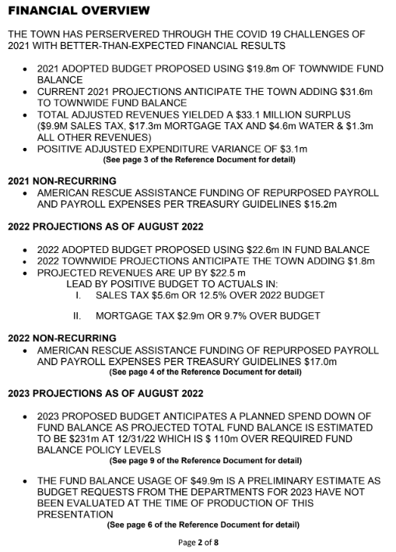

EXHIBIT T-PAGE 3 OF 8

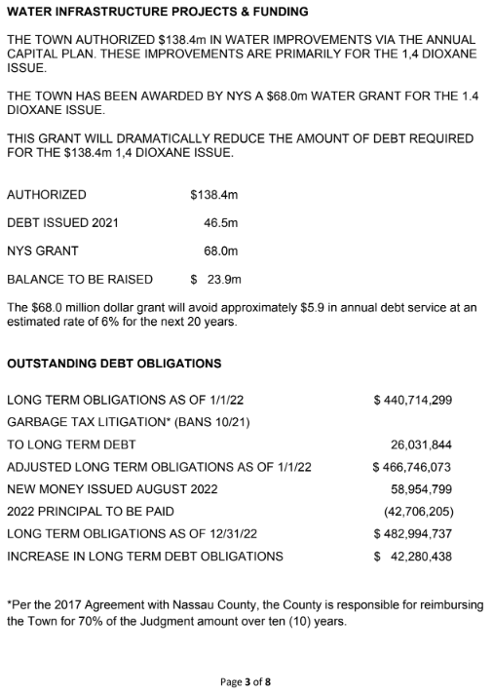
EXHIBIT T-PAGE 4 OF 8

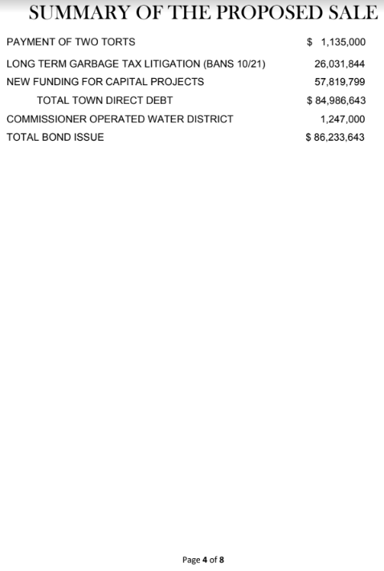

EXHIBIT T-PAGE 5 OF 8



EXHIBIT T-PAGE 6 OF 8



EXHIBIT T-PAGE 7 OF 8

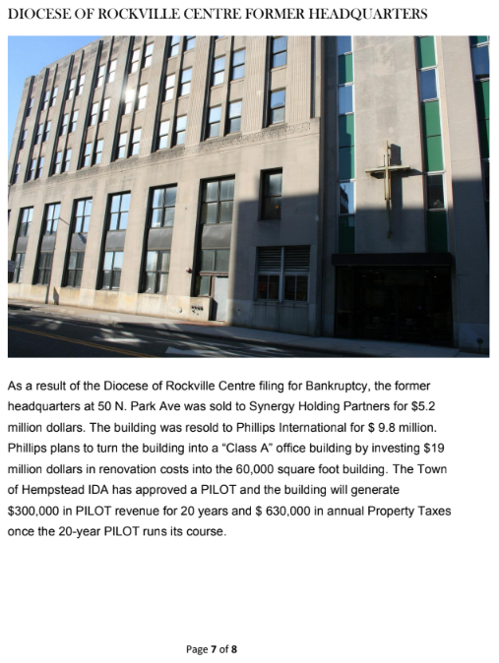

EXHIBIT T-PAGE 8 OF 8

